MODEL: TX880 SPK
PICTURE
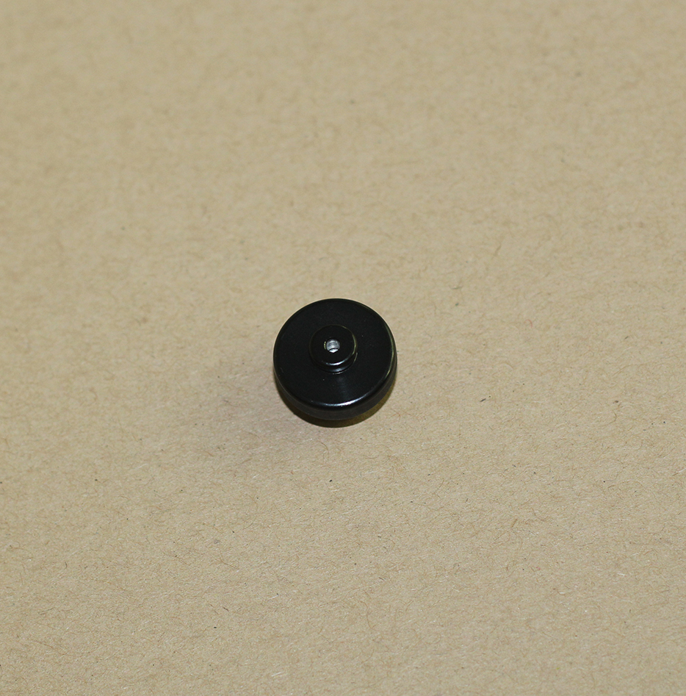

SPECIFICATION
Type | Transducer Moving coil dynamic speaker
Impedance | 90Ω±15% @1KHZ
Sensitivity | 120±3dB @1KHZ
Resonance freq | (F0) 400HZ±20%
Frequency respond | F0~9KHz
Rated input power | 500mW
Maximum input power | 1000mW
Suitable for | Earphone TX880,TX885,TX850,TX880L series

